Computational Evolution Project Plan

We aim to model an environment with several creatures living inside it. We then hope to perform experiments on the system and investigate a particular event in evolutionary history for example the Cambrian Explosion.

Week 1

Set up basic classes such as Environment, Creature etc. to simulate single-species reproduction. Also set up necessary classes to output this information to an image using the libraries PyGame and PyTMX.

This was completed on time. Previous experience with the PyGame and TMX library enabled us to rapidly produce visual output and a simple simulation with only exponential growth.

Week 2

Connect the two elements made in week 1 to improve debugging given the large amount of data. Implement resources, natural variation of genetic parameters and output of data to ‘save files’ for subsequent analysis.

The two elements in week 1 were connected as expected as were resources and natural variation and save files using cPickle library.

Saving files has significantly slowed simulation times and increased RAM usage. Uwais’ laptop runs out of RAM after ~400 steps

Week 3-4

Implement loading from save-state files so that longer experiments can be run conveniently. Incorporate analysis of these save-state files such that useful results can be extracted from the experiments run in week 7-8. Implement more intelligent motion of creatures to allow for more complex scenarios to emerge.

Files can now be loaded from save-states. A flexible analysis class has been added to allow for many different types of graphs to be plotted. Vision has been added to increase complexity of the simulations.

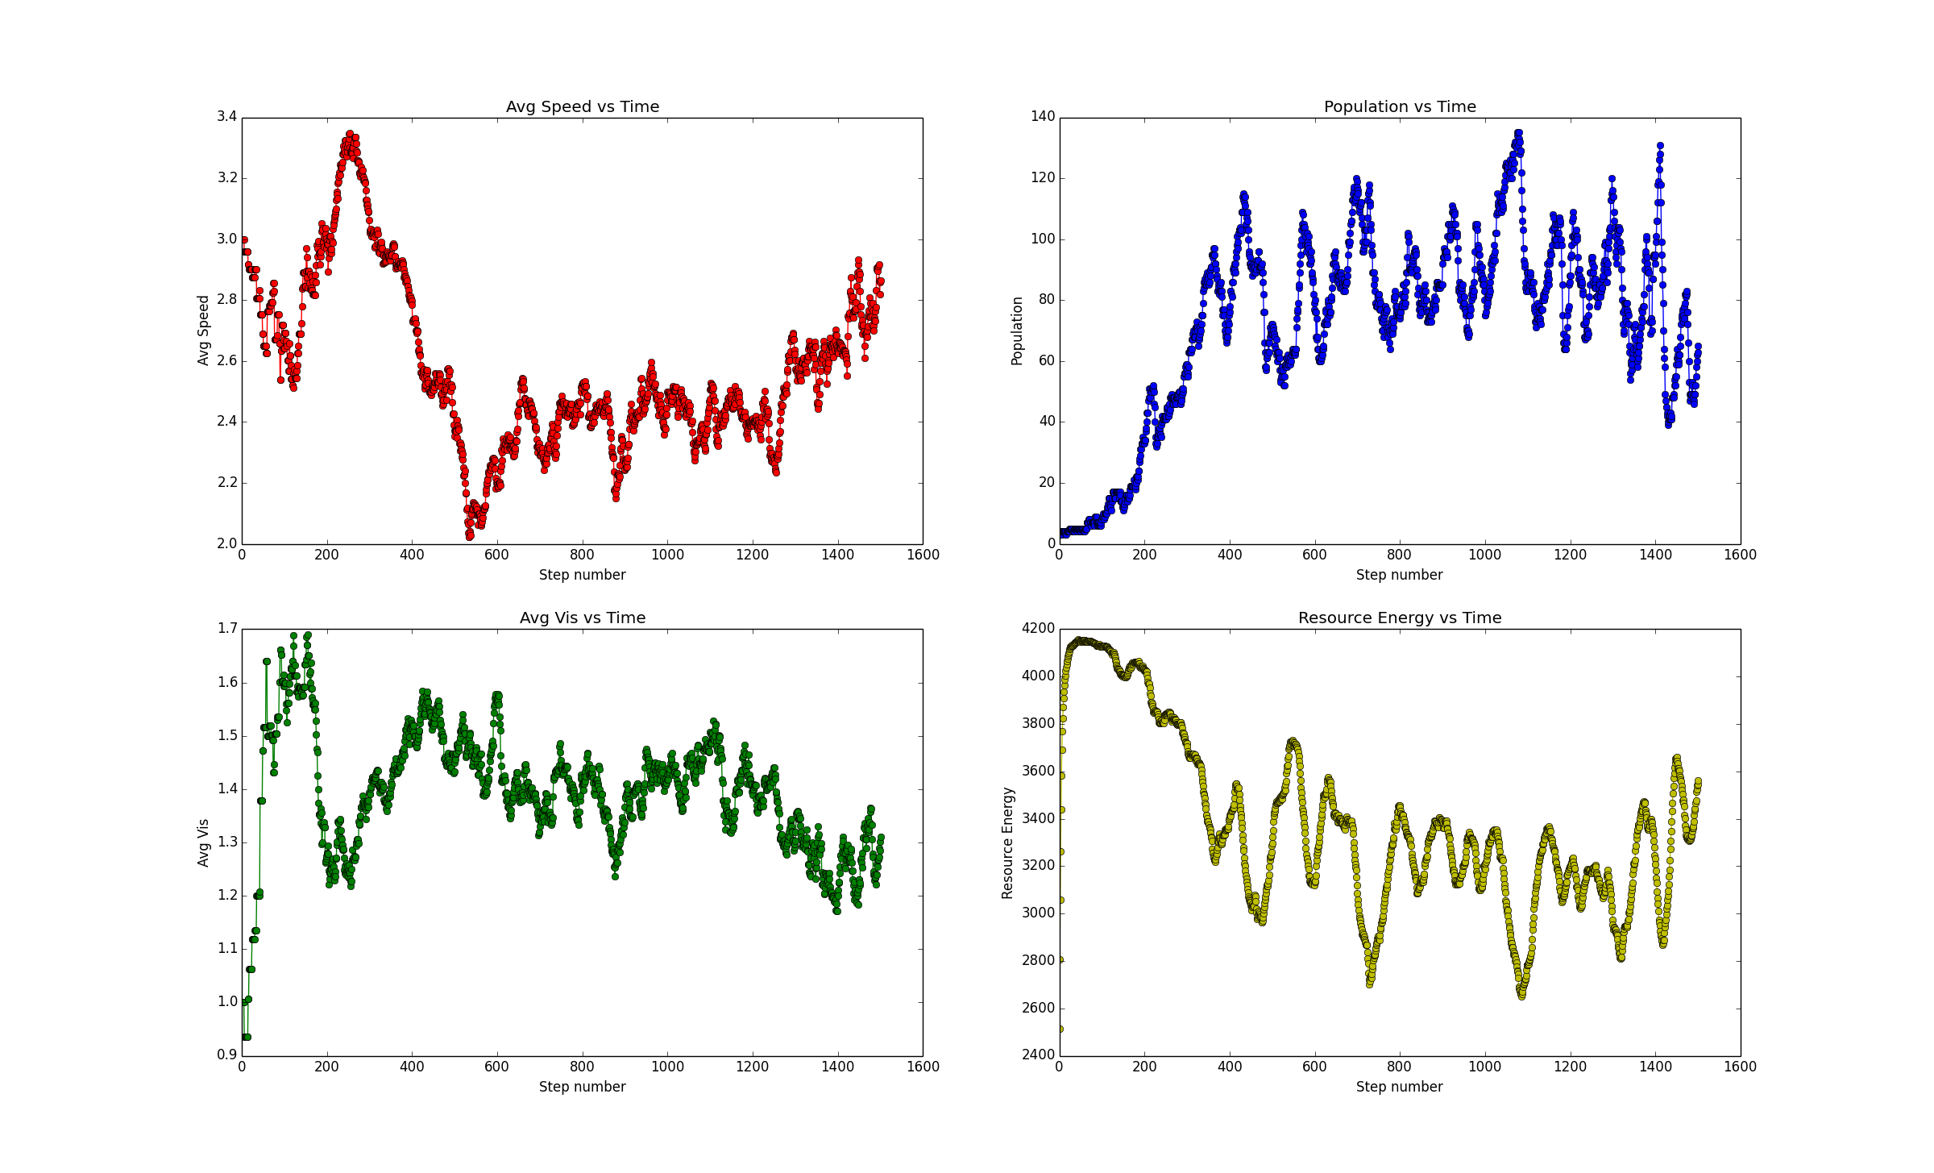

Simulations are now very slow – this needs to be fixed

Massive optimisations – Resource class eliminated for now. It has become a mapWidth x mapHeight numpy array. Save state is now saves deadCreatures incrementally and livingCreatures utilises numpy arrays to speed up saving. **Like-for-like simulations have been sped up by ~200x. Memory (RAM/Storage) usage has been reduced by ~3000x**

Week 5-6

Implement multiple species and look out for emerging predator-prey relationships. Allow for species to be defined during an experiment automatically based upon parameters straying a particular distance from the original species definition.

Vision was changed to include a parameter for how far away a resource is to prevent certain patterns of non-intelligent movement. Graphing now includes a scatter graph type to illustrate the distribution of genetics. For example, speed vs. reproduction threshold. This plot will help us create a self-sustaining species definition that works well in many different conditions

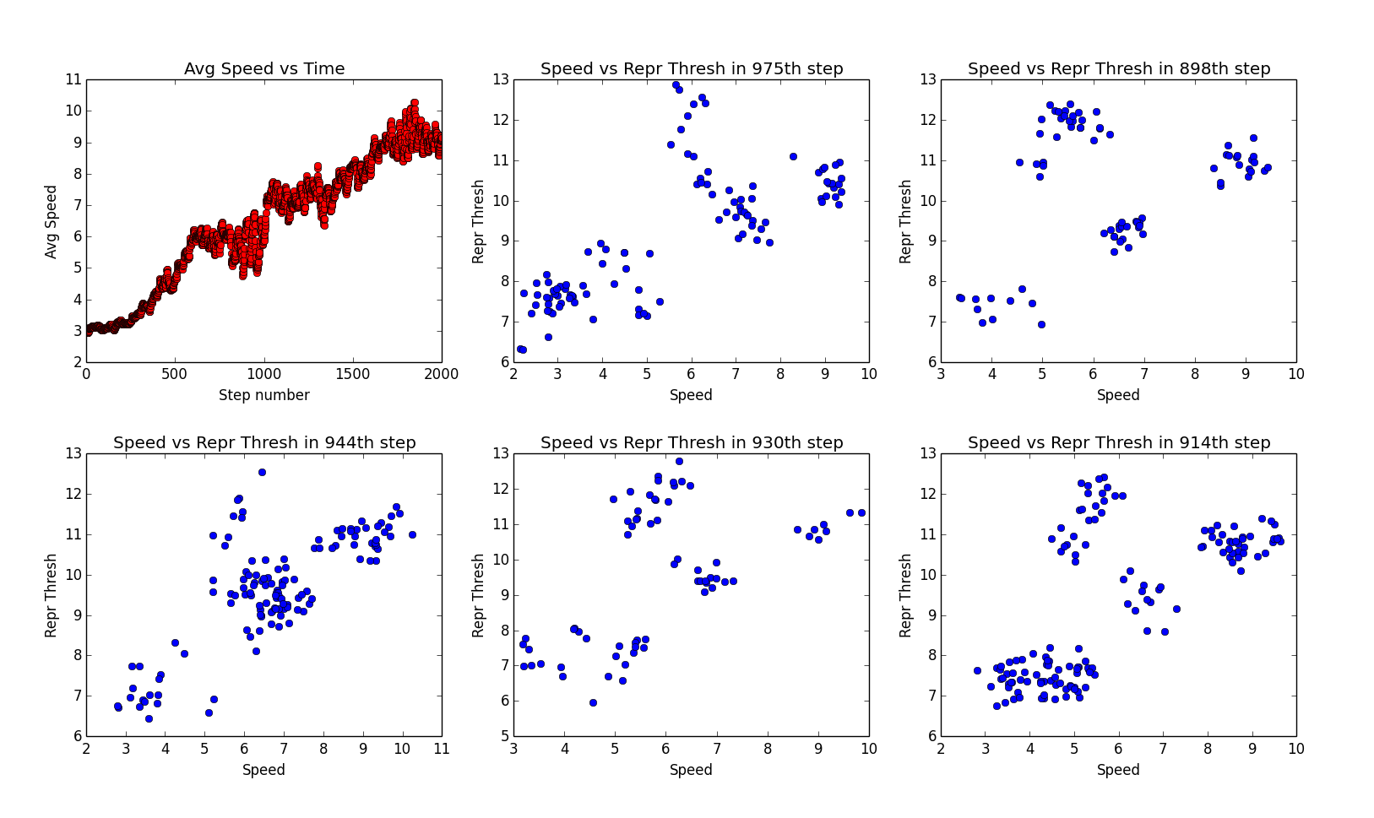

Week 7-8

Investigate the effects of sudden/gradual changes such as lack of resources (primordial Mars) or the extinction of a predator (extinction of the dinosaurs). Observe how this changes the environment and if the system follows what happened historically.